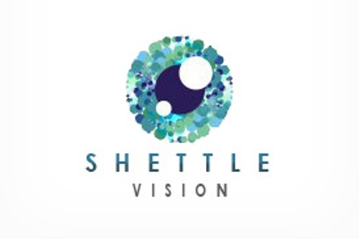
Retinal Imaging Consent Form
In our continued efforts to bring the most advanced technology available to his patients, Dr. Todd Shettle is proud to announce the addition of the Carl Zeiss Visucam Retinal Digital Camera to his practice, greatly enhancing his ability to assess and monitor your eye health.
Our eyes are important to us and since implementing the retinal screening technology, many of our patients have benefited from early detection of macular degeneration, diabetes, high blood pressure, glaucoma, retinal detachments and other systemic diseases. These conditions can develop without warning and progress without any symptoms.
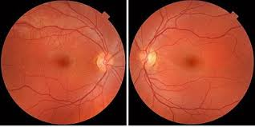

Early diagnosis and prevention is crucial and the Carl Zeiss Visucam Camera provides:
- An eye wellness scan
- An in depth view of the retinal layers (where disease can start)
- The ability to review your retinal image with your doctor during the exam.
- A permanent digital record for your medical file, which gives your doctor comparisons for tracking and diagnosing potential eye disease.

In most cases, this type of screening is not covered by your insurance plan. Most insurances do not cover advanced screening tools such as the Carl Zeiss Visucam Camera. Dr. Todd Shettle strongly believes that it is in your best medical interest to have the Visucam imaging. The screening fee is $39. If you have any questions regarding this screening, please do not hesitate to ask Dr. Shettle or any of the Shettle Vision staff.

________ I elect to have photos taken
_________ I elect not to have photos taken

Date _____/_____/_____ Patient Signature __________________________________

